<Vendor Name> Service Provider Deployment Guide

For Odin Automation Premium

Revision n.n (Month dd, yyyy)

Contents
Preface 5
Documentation Conventions 5
Typographical Conventions 5
General Conventions 6
Feedback 7
Introduction 8
About This Guide 8
Audience 8
Terms and Abbreviations 8
Business Model Overview 9
<Vendor Name> Services Provided 9
Service Hierarchy Exposed by SPro 10
Customer’s Workflow 11
The integration workflow looks as follows: 11
Customer’s Lifecycle 12
Service Hierarchy Subscription Modification Options 12
Localization List 13
Revision History 13
Contractual contact information for <Vendor Name> 15
Support Expectations 15
Technical Integration Overview 16
General Architecture 16
<Vendor Name> Services Provided 17
<Vendor Name> Object Mapping 17
Integration Prerequisites 17
Prepequisites for <Vendor Name> Application 17
Prerequisites for <Components> 18
Specific Prerequisites 19
Deploying <Vendor Name> Application 20
Deploying <Vendor Name> APS Package 21
Preparing Provisioning Host 21
Register Provisioning Host in POA 21
Install Additional Required Software 21
Mark Provisioning Host with Provisioning Attribute 21
Mark Provisioning Host as Ready to Provide 21
Importing <Vendor Name> Application 21
Configuring Services for Selling - POA 23
Resource Creation 24
Service Template Creation 24
Branding Options 25
Localization 25
Configuring Services for Selling - PBA 26
Service Plans 26
Bundling or Composite Resource Creation 26
Adding to Order Forms 26
Reseller options 26
Index 27

Chapter 1

Preface
In This Chapter
Documentation Conventions 5
Feedback 7

Documentation Conventions
Before you start using this guide, it is important to understand the documentation conventions used in it.

Typographical Conventions
The following kinds of formatting in the text identify special information.
Formatting convention | Type of Information | Example
Special Bold | Items you must select, such as menu options, command buttons, or items in a list. | Navigate to the QoS tab.
 | Titles of modules, sections, and subsections. | Read the Basic Administration module.
Italics | Used to emphasize the importance of a point, to introduce a term or to designate a command line placeholder, which is to be replaced with a real name or value. | These are the so-called shared VEs.  To destroy a VE, type vzctl destroy VEid.
Important | An important note provides information that is essential to the completion of a task. Users can disregard information in a note and still complete a task, but they should not disregard an important note. | Important: The device drivers installed automatically during Setup are required by your system. If you remove one of these drivers, your system may not work properly.
Note | A note with the heading “Note” indicates neutral or positive information that emphasizes or supplements important points of the main text. A note supplies information that may apply only in special cases—for example, memory limitations, equipment configurations, or details that apply to specific versions of a program. | Note: If Windows prompts you for a network password at startup, your network is already set up and you can skip this section.
Monospace | The names of commands, files, and directories. | Use vzctl start to start a VE.
Preformatted | On-screen computer output in your command-line sessions; source code in XML, C++, or other programming languages. | Saved parameters for VE 101
Preformatted Bold | What you type, contrasted with on-screen computer output. | # rpm –V virtuozzo-release
CAPITALS | Names of keys on the keyboard. | SHIFT, CTRL, ALT
KEY+KEY | Key combinations for which the user must press and hold down one key and then press another. | CTRL+P, ALT+F4

General Conventions
Be aware of the following conventions used in this book.
- Modules in this guide are divided into sections, which, in turn, are subdivided into subsections. For example, Documentation Conventions is a section, and General Conventions is a subsection.
- When following steps or using examples, be sure to type double-quotes ("), left single-quotes (`), and right single-quotes (') exactly as shown.
- The key referred to as RETURN is labeled ENTER on some keyboards.
Commands in the directories included into the PATH variable are used without absolute path names. Steps that use commands in other, less common, directories show the absolute paths in the examples.

Feedback
If you have found a mistake in this guide, or if you have suggestions or ideas on how to improve this guide, please send your feedback using <insert link or email address here>. Please include in your report the guide's title, chapter and section titles, and the fragment of text in which you have found an error.

Chapter 2

Introduction
In This Chapter
About This Guide 8
Audience 8
Terms and Abbreviations 8

About This Guide
This guide describes the integration of Odin Automation with <Vendor Name>.
This document was developed by <Vendor Name>. For additional information, please contact <email>.

Audience
This guide is intended for:
- Providers that use Odin Automation and want to sell <Vendor Name> services to customers.
- Technical support engineers that configure <Vendor Name> services.

Terms and Abbreviations
- APS ‒ Application Packaging Standard, an open standard that was designed to simplify the delivery of SaaS applications in the cloud-computing industry.
- OA ‒ Odin Automation, which includes both OA and BA.
- BA ‒ Business Automation.
- OA ‒ Operations Automation.
- Add <Vendor Name> terms

Chapter 3

Business Model Overview
This section contains an outline of how the integration of <Vendor Name> and OA is consumed by the end customer and the list of <Vendor Name> features that are supported within the integration package.

<Vendor Name> Services Provided
Describe services and describe the hierarchy of users exposed by the integration

Ex:
SPro allows a small business to manage multiple websites from one location.

SPro APS package allows an SMB to purchase SPro from the service provider. The SMB then has the ability to create service users accounts for each of their employees requiring the solution provided by SPro. Each employee then has the ability to login to the CCP with the service user account credentials and deploy a new license of SPro. After the service user deploys a new SPro license, they must allocate an allotment of disk space to that license out of the pool of disk space that has been assigned to them.

Each Employee with then be able to use their instance of the SPro product. The SMB will be billed for that license on a monthly basis. Any overages in disk space usage will result in additional charges to the SMB at the rate set by the service provider.
The SMB will have the ability to cancel individual license of SPro when they are no longer needed to avoid unnecessary service charges.

Table of billable offerings of SPro
Attribute | Type | Period
Bandwidth Usage | bandwidth | m/q/y
License | Item count | One-time fee
Disk Usage | Space | m/q/y
Email accounts | Item count | m/q/y

Service Hierarchy Exposed by SPro
- SPro SMB Account
  - SPro service user account
    - SPro License
      - SPro disk quota
    - SPro Archiving
    - SPro Mobile Access

Customer’s Workflow

The integration workflow looks as follows:
- Numbered list of steps the customer follows to use <Vendor Name>.

<Insert Drawing Here>

Customer’s Lifecycle

<Vendor Name> allows the customer to use the service after the initial setup work flow is complete. If the customer wishes to upgrade their xyz allocation they can do so at any time in the billing cycle.

Indicate which services in the services hierarchy can be turned on or off and upgraded or downgraded

Service Hierarchy Subscription Modification Options
- SPro SMB Account
  - SPro service user account (Upgrade/Downgrade between 3 tiers allowed)
    - SPro License (Cannot switch license types)
      - SPro disk quota (Upgrade/Downgrade usage not needed, OA resource tiers can be used to apply overage rates)
    - SPro Archiving (Once activated, cannot be removed)
    - SPro Mobile Access (Can be removed at any time)
Chapter 4

Localization List
<Vendor Name> has been localized in the following languages for each category
- Customer Interface
  - EN
  - ES
  - FR
- OA task manager error logging
  - EN
- <Vendor Name> API error messaging
  - EN
- <Vendor Name> external communication to customer
  - (Only in EN/Linked to the customer’s CCP locale)

Revision History
1.0 Build 3
- Changes
1.0 Build 2
- Changes
1.0 Build 1
- Changes

Contractual contact information for <Vendor Name>
Service Providers using Odin Automation should contact the following to initiate the reseller account creation process by executing the required contracts before <Vendor Name> can be resold.

Support Expectations
Describe the support process a Odin Automation service provider offering <Vendor Name> will follow when setting up the offering and when customer’s using <Vendor Name> require support.

Technical Integration Overview

This section contains an outline of how the integration of <Vendor Name> and OA is performed and the list of <Vendor Name> features that are supported within the integration package.

General Architecture
The following scheme represents the architecture of OA and <Vendor Name> integration:
<Insert Drawing or link Here>
<sample drawings, real sample>
The integration scheme comprises the following parts:
- Bulleted list of components
- Data flows to or from Odin Automation
- Network ports used if special ports need to be opened
- Protocols used
The integration workflow looks as follows:
Numbered list of steps with.
<Insert Drawing Here>

<Vendor Name> Services Provided
Describe services

<Vendor Name> Object Mapping
Describe the objects created by the service and how they map to Odin Automation objects. For example, an Odin Automation subscription corresponds to an account in the external portal provided by <Vendor Name> and Odin Automation service users correspond to users in the portal provided by <Vendor Name>.

Integration Prerequisites
Before you start integrating <Vendor Name> into OA, learn about necessary preparations the process.

Prerequisites for <Vendor Name> Application
Describe prerequisites
Required OSA version, CCP version.

Prerequisites for <Components>
General criteria:
Server Names
Description
Density
Quantity
OS
Software
Supported Virtualization
Provisioning System
CPU
RAM
Disks
Disk Partitioning
NICs
Note: It is highly recommended using recommendations of the OA Application Module (application hosing guide).
Also there are some additional software requirements to your Provisioning Host.
After registering the host in OA, the software specified in the following table must be installed on it:
Software Name
Java, version 6
Java libraries as follows: | Get these libraries from <Vendor Name> Java library, which is usually found at the following path: <Vendor Name>/lib/jars.

Prerequisites for APS Endpoint
General criteria: PHP 5.4 or higher on the Endpoint

Preparing Endpoint Host Server
<Vendor Name>APS Package requires an application host server to be setup before it can be successfully imported and used in OA. This endpoint server can be provisioned as a VPS or a VM in the same infrastructure as OA systems. Please make sure you have OA (OA + BA) infrastructure set up properly before continuing. The Provider guide for setting up OA can be found at http://download.automation.odin.com/oa/7.1/oapremium/portal/en/home/index.html .

The following tools are required to be installed on the application endpoint server:
- Apache HTTP Server 2.4
- OpenLDAP 2.4
- PHP 5.4 (with LDAP module enabled)
- APS PHP Runtime

This deployment instruction is based on fresh install of CentOS 7. All required packages are installed and managed by its yum package manager.
- Install PHP interpreter via yum install php and Apache HTTP server via yum install httpd if your Linux distribution hasn’t come with them. Please check your installed version of PHP via:
[root@endpoint ~]# php --version

And ensure your Apache HTTP server is up and running:
[root@endpoint ~]# service httpd status
httpd (pid 5749) is running...
The default document root directory for Apache HTTP Server is located at /var/www/html/.
- The application host server requires the APS PHP Runtime library. The PHP runtime library can be downloaded from: https://doc.apsstandard.org/resources/downloads/#php-runtime-library/
To install PHP runtime onto your server, do following:
[root@endpoint~]# rpm -ivh aps-php-runtime-{version}.noarch.rpm
Where aps-php-runtime-{version}.noarch.rpm is the name of PHP runtime library, and the {version} is the version number you download from the above link. After the install, the /usr/share/aps/php directory will be added to the system php.ini file automatically.
- Upload the <Vendor Name> APS package zip file (i.e., app-aps2-xx-xx.app.zip) onto your application host server, where app-aps2-xx-xx.app.zip is the name of the package and xx-xx is the place-holder for a specific version of APS package. This guide assumes you place it under /root/app-aps2-xx-xx.app.zip.

- The application endpoint server setup can be fully automated with a batch script, which can be obtained from http://doc.apsstandard.org/_downloads/endpoint.sh. Issue following command to obtain this batch script:
[root@endpoint~]# wget http://doc.apsstandard.org/_downloads/endpoint.sh

- Use the endpoint.sh utility to setup your application host server in a specified folder. E.g.,, if you have package app-aps2-1-30.app.zip and need to install the application endpoint in folder /var/www/html/app, enter the following command:
[root@endpoint ~]# endpoint.sh app app-aps2-1-30.app.zip
The batch script will print out the URL for the endpoint, e.g., http://endpoint-ip-or-dns/app/.
- Verify if the application endpoint server has been successfully installed and configured by visiting one of APS service URLs in your browser, such as http://endpoint-ip-or-dns/app/globals.php, the server must reject it for security reasons with a response similar to the following:
{
"code": 404,
"type": "RuntimeException",
"message": "Not Found: No appropriate method found for…."
}

Specific Prerequisites
<Insert general prerequisites here>.

Chapter 4

Deploying <Vendor Name> Application
It is assumed that providers deploy <Vendor Name> by themselves with the needed configuration and then import the <Vendor Name> APS package to OA and configure <Vendor Name> service offerings for selling. (In this case, the integration of OA and <Vendor Name> in the frame of APS package does not include <Vendor Name> deployment and <Vendor Name> infrastructure management.)
For information about <Vendor Name> deployment, see <insert URL here> .

Chapter 5

Deploying <Vendor Name> APS Package
To deploy the <Vendor Name> APS package on the Provisioning Host, you need to prepare the host and then import your <Vendor Name> APS package in OA. Find information about how to do it in this section.
In This Chapter
Preparing Provisioning Host 14
Importing <Vendor Name> Application 15

Importing <Vendor Name> Application
To Import the <Vendor Name> application to OA:
- In the control panel, go to Top > Service Director > Application Manager > Applications. The list of the applications appears.
- Click the Import Package button.
- Import the application from the local workstation, select the local file option, and specify the path to the application file using the Browse... button.
- Select the Enabled (available in subscriptions) checkbox.
- Click the Submit button.

Chapter 6

Upgrading the Application
To upgrade the APS package, you need to import the APS package into Odin Service Automation and then upgrade the package in the PCP.
1. Copy the new package to the endpoint host via scp, winscp or any other tool in
/var/www/html. For example:
$ scp app-aps2-1-31.app.zip root@endpoint.a.org.apsdemo.org:/var/www/html

2. Execute the following command to upgrade endpoint:
# endpoint --upgrade app app-aps2-1-31.app.zip
3. Now go to the PCP and import the new package version (see section above).
4. Go to the instance of the application and click the General tab.
5. Click the Upgrade instances button, and choose whether you want to upgrade all
instances or select a specific one.
6. Click Next.
7. Click Finish.
8. Verify that the status is Ready and that the new version is correct

Configuring Services for Selling - OA
In This Chapter
Resource Types Creation 16
Service Template Creation 16
Branding Options 16
Localization 16

Service Provider’s Instance creation and Global Variables

Global Setting is the first resource that is required to be created after the <Vendor Name>APS package has been imported into OA platform. As this name indicates, this is package-wise resource, meaning it should be created once by the POA Service Provider, neither customer administrator nor service user is required to create such resource.

In order to create Global Settings and other resource types, we are required to create an instance of this package. Please follow the steps:

- Log in to OA as service provider administrator.
- Go to Services -> Applications and select <Vendor Name> APS package.
- Switch to “Instances” tab and click “Install” button.
- Provide the endpoint server URL in the field “Application API end-point URI”, which takes a form of http://[application-endpoint-server-ip]:[port]/[package-name]/. Here:
- [application-endpoint-server-ip] the IP address of your application server;
- [port] the port number your Apache Server is listening on, e.g., 80.
- [package-name] is the name of your web application in which we deploy the package scripts, e.g., numecentaps2.

Resource Types Creation
- Steps to create each required resource type
- Must include information on how or where Global Setting values can be obtained.
- Must include provisioning attribute requirements.
<include screen shots and example scenario>

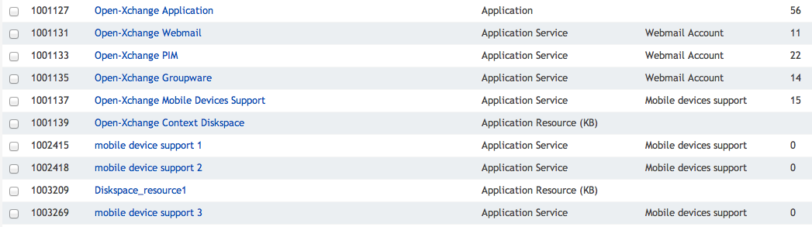
Table of required resource types with following columns: resource type name, resource class name, autoprovisioning enabled.

Service Template Creation
- Steps to create a properly configured Service Template with the ability to provision <Vendor Name> in the environment appropriate to the application. Hosted applications should include the details appropriate to the needs of the application.
<include screen shots and example scenario>

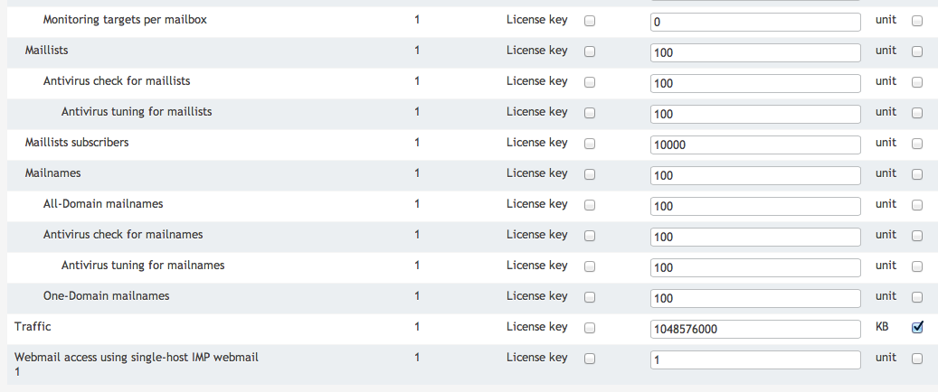

Branding Options
- If <Vendor Name> is designed for custom branding, describe the resource settings needed to custom brand the application.

Localization
- Meta file localization
- List the languages supported by <Vendor Name> in the meta file Settings.
- Error handling localization
- List the languages supported by <Vendor Name> in the error handling scripts used to identify error messages to the provider.
- Localization limitations
- List any limitations in localization for <Vendor Name>. Ex: the email messages generated by <Vendor Name> will only be in English.

To request additional languages, please contact <insert email address>

Configuring Services for Selling - PBA
Learn about how to configure the service templates that are necessary to form <Vendor Name> APS subscriptions for sale.
In This Chapter
Service Plans 17
Bundling or Composite Resource Creation 17
Adding to Order Forms 17
Reseller Options 17

Service Plans
- Steps to create the Service Plans.

Bundling or Composite Resource Creation
- Steps to create service bundles with complementary services.

Adding to Order Forms
- Steps to apply <Vendor Name> to a PBA order form.

Reseller options
- Steps to delegate <Vendor Name> to OA reseller accounts.

Index
<Update to appropriate terms and pages>
<
<Vendor Name> Services Provided - 9
<Vendor Name> Subscriptions Configuration Overview - 17, 19
A
About This Guide - 8
Audience - 8
C
Configuring Services for Selling - 16, 19
Creating <Vendor Name> Application Resource Type - 17, 19
Creating <Vendor Name> Diskspace Resource Type - 18, 19
Creating <Vendor Name> Service Resource Types - 18, 19
D
Deploying <Vendor Name> Application - 13
Deploying <Vendor Name> APS Package - 14
Documentation Conventions - 5
F
Feedback - 7
G
General Architecture - 9
General Conventions - 6
I
Importing <Vendor Name> Application - 14
Installing Additional Required Software - 14
Integration Overview - 9
Integration Prerequisites - 9
Introduction - 8
M
Marking Provisioning Host as Ready to Provide - 14
Marking Provisioning Host with Provisioning Attribute - 14
P
Preface - 5
Preparing Provisioning Host - 14
Prepequisites for <Vendor Name> Application - 10
Prerequisites for Associating <Vendor Name> with BES - 12
Prerequisites for Provisioning Host - 11
R
Registering Provisioning Host in POA - 14
T
Terms and Abbreviations - 8
Typographical Conventions - 5

