<Vendor Name> Integration Subscriber's Guide

For Odin Automation

Revision n.n (Month dd,yyyy)

<partner logo>

Contents
Preface 4
Documentation Conventions 4
Typographical Conventions 4
General Conventions 5
Feedback 6
Introduction 7
About <Vendor Name> Services 7
Audience 7
<Vendor Name> Configuration Overview 8
Typical Scenarios of <Vendor Name> Usage 9
SPro Business Account Creation 10
SPro User Account Creation 11
SPro User License Assignment 12
SPro Quota Assignment to a License 12
Advanced Scenarios of <Vendor Name> Usage 13
Scenario 5 13
Scenario 6 13
Scenario 7 13
Index 14

Chapter 1

Preface
In This Chapter
Documentation Conventions 4
Feedback 6

Documentation Conventions
Before you start using this guide, it is important to understand the documentation conventions used in it.

Typographical Conventions
The following kinds of formatting in the text identify special information.
Formatting convention | Type of Information | Example
Special Bold | Items you must select, such as menu options, command buttons, or items in a list. | Navigate to the QoS tab.
 | Titles of modules, sections, and subsections. | Read the Basic Administration module.
Italics | Used to emphasize the importance of a point, to introduce a term or to designate a command line placeholder, which is to be replaced with a real name or value. | These are the so-called shared VEs.  To destroy a VE, type vzctl destroy VEid.
Important | An important note provides information that is essential to the completion of a task. Users can disregard information in a note and still complete a task, but they should not disregard an important note. | Important: The device drivers installed automatically during Setup are required by your system. If you remove one of these drivers, your system may not work properly.
Note | A note with the heading “Note” indicates neutral or positive information that emphasizes or supplements important points of the main text. A note supplies information that may apply only in special cases—for example, memory limitations, equipment configurations, or details that apply to specific versions of a program. | Note: If Windows prompts you for a network password at startup, your network is already set up and you can skip this section.
Monospace | The names of commands, files, and directories. | Use vzctl start to start a VE.
Preformatted | On-screen computer output in your command-line sessions; source code in XML, C++, or other programming languages. | Saved parameters for VE 101
Preformatted Bold | What you type, contrasted with on-screen computer output. | # rpm –V virtuozzo-release
CAPITALS | Names of keys on the keyboard. | SHIFT, CTRL, ALT
KEY+KEY | Key combinations for which the user must press and hold down one key and then press another. | CTRL+P, ALT+F4

General Conventions
Be aware of the following conventions used in this book.
- Modules in this guide are divided into sections, which, in turn, are subdivided into subsections. For example, Documentation Conventions is a section, and General Conventions is a subsection.
- When following steps or using examples, be sure to type double-quotes ("), left single-quotes (`), and right single-quotes (') exactly as shown.
- The key referred to as RETURN is labeled ENTER on some keyboards.
Commands in the directories included into the PATH variable are used without absolute path names. Steps that use commands in other, less common, directories show the absolute paths in the examples.

Feedback
If you have found a mistake in this guide, or if you have suggestions or ideas on how to improve this guide, please send your feedback to <insert link or email address here>. Please include in your report the guide's title, chapter and section titles, and the fragment of text in which you have found an error.

Chapter 2

Introduction
In This Chapter
About <Vendor Name> Services 7
Audience 7

About <Vendor Name> Services

Audience
This guide is for Providers using Odin Automation looking to understand their customer’s experience when they buy the Odin Automation subscription with <Vendor Name> services included.
This document was developed by <Vendor Name>. For additional information, please contact <email>.

Chapter 3

<Vendor Name> Configuration Overview
With the aid of the <Vendor Name> Configuration OA option you can see common information about your <Vendor Name> service and configure general settings of the service. This includes defining all the domains propagated to <Vendor Name> and used for mailboxes, distribution lists and so forth. Also here you can create new service users and change setting specified to the service.

Chapter 4

Typical Scenarios of <Vendor Name> Usage
<sample>
Creating the Business account in SPro APS instance

Learn about the most common operations that you can perform within your <Vendor Name> APS subscription.
In This Chapter
SPro Business Account Creation 9
SPro User Account Creation 9
SPro User License Assignment 9
SPro Quota Assignment to a License 9

SPro Business Account Creation
<add details and screenshots here>

The first step in provisioning the SPro application is to create the SPro Business Account. The SMB’s account administrator will login to the Odin Automation Customer Control Panel using the login credentials created during their initial purchase. After login, the account administrator will select the SPro subscription if it is not already selected.

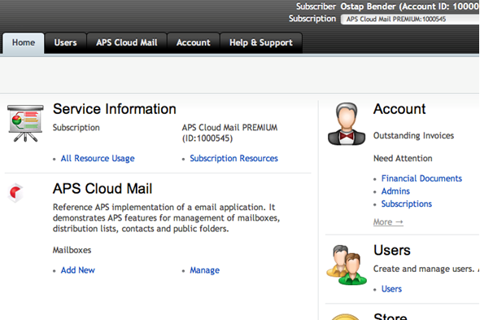

The account administrator will click the “install” link below the <Vendor Name> description to start the install process.

SPro User Account Creation
<add details and screenshots here>

The second step in provisioning the SPro application is to create the SPro User Accounts. The SMB’s account administrator will login to the Odin Automation Customer Control Panel using the login credentials created during their initial purchase. After login, the account administrator will select the SPro subscription if it is not already selected.

The account administrator will click the “manage” link below the <Vendor Name> description then “add user” to assign users to the service.

SPro User License Assignment
<add details and screenshots here>

SPro Quota Assignment to a License
<add details and screenshots here>

Chapter 5

Advanced Scenarios of <Vendor Name> Usage
Learn about some advanced operations that you can perform within your <Vendor Name> OA subscription.
In This Chapter
Scenario 5 19
Scenario 6 20
Scenario 7 20

Scenario 5
<add details here>

Scenario 6
<add details here>

Scenario 7
<add details here>

Index
<Update to appropriate terms and pages>
A
About SPro Services - 7
Advanced Scenarios of SPro Usage - 11
Audience - 7
C
Changing Mailbox Size - 9
Creating Additional E-mail Addresses for Mailbox - 9
Creating Mailbox - 9
D
Documentation Conventions - 4
E
Enabling Archiving for Mailbox - 10
F
Feedback - 6
G
General Conventions - 5
I
Introduction - 7
M
Managing Advanced SPro Features - 11
Managing Domains Propagated to SPro - 11
P
Preface - 4
Processing Other Advanced Scenarios of SPro Usage - 11
T
Typical Scenarios of SPro Usage - 9
Typographical Conventions - 4
Z
SPro Configuration Overview - 8

