Odin
Service Design Document - Template
Application X

Contents
Document Changelog 2
Introduction 3
Requirements 4
Personas 4
Scenarios 4
Provider 4
Reseller 4
Customer Admin 4
Customer End-User 4
Functional Requirements 4
Application Lifecycle 5
Service Lifecycle 5
User Lifecycle 6
Domain Lifecycle 6
Integrations with other Applications 6
Identity Management 6
Migrations 6
Non-Functional Requirements 7
Service Dependencies 7
Deployment of Service 7
Branding 7
Support 7
Localization 7
Billing & Licensing 7
Design 9
Resource Model 9
UX Mockups 11

Introduction

Put here short introduction about the service itself and planned integration via APS application.

Note: See “Service Design Document – Instructions” for a detailed explanation how to fill out this document.

Requirements
Provide here Odin Automation Premium version (e.g. 7.0 or 7.1) and version of CCP (1 or 2) the application is developed for.

Personas
List here which Personas (from common OA personas) will use this application. These personas should also be used in description of scenarios in next section. Keep the link to online description of common OA personas to avoid duplication of content here.
• Customer - Samantha (SMB Owner)
• Customer - Andrew (IT Admin)
• End-User - Emily (Employer)
• Reseller - Jim
• Provider Staff - Steven (Product & Marketing Manager)
• Provider Staff - Nik (Operations Manager)

Scenarios
Provide here a list of scenarios that the APS application will supply. Start with this exercise. There is no template/checklist for this on purpose since different applications/services will have very different scenarios and they should come from business needs, not technical functions of the platform.
Here is a sample scenario for package import and global settings configuration scenario.
Provider wishes to change Global Settings – 1.1 Goal Provider changes the values of Global Settings variables.
Preconditions
Steven has successfully deployed the package and created an application instance.
Story
1. Steven accesses OA Control Panel.
2. Navigates to Applications list.
3. Selects the TestApplication APS application.
4. Steven navigates to an application instance.
5. Steven clicks the “Global settings” tab.
6. Clicks “Edit” button.
7. Edits one or more listed fields.
a. API Username
b. API Password
c. API URL
8. Steven clicks the “Save Changes” button.

Provider

Reseller

Customer Admin

Customer End-User

Functional Requirements
Use this section to validate that you have thought through all scenarios the application needs. Write for each section which scenario covers this, how application should react or if not applicable.

Application Lifecycle

Install Application End-Point

Configure Application Instance

Upgrade Application

Remove Application

Monitor Application

Create Paid Service Offer

Create Trial Service Offer

Create Freemium Service Offer

Modify Service Offer for new customers

Modify Service Offer for existing customers

Service Lifecycle

Create new Paid Subscription

Create new Trial Subscription

Create new Freemium Subscription

Send welcome e-mail for Service to customer

Show introduction to Service in Control Panel

Convert Trial to Paid Subscription

Convert Freemium to Paid Subscription

Increase Subscription limits

Decrease Subscription limits

Switch between Resources within Subscription

Switch Subscription to other Offer

Buy additional Subscription

Renew existing Subscription

Suspend existing Subscription

Resume existing Subscription

Move Subscription to new Customer

Move Customer to new Reseller

Bill Subscription for fixed fees

Bill Subscription for usage

Application-specific configuration for customer account

User Lifecycle

Assign Service to end-user

Remove Service from end-user

Configure Service for end-user (by customer admin)

Configure Service for end-user (by user)

Domain Lifecycle

Assign a domain to the service

Remove a domain from the service

Integrations with other Applications
If applicable list here how the application will interact with services from other applications:
- During Purchase
- During Provisioning
- During Configuration
- During Consumption

Identity Management
Describe how/if Customer end-user, Customer Admin and/or Provider or Reseller staff can log-in from OA to the service or from the service back to the OA control panel.
- Technology supported
- Log-in directly to application
- Log-in from OA to application as customer
- Log-in from the service to OA
- Can users be created and managed directly at service?
- Can users be managed on OA side?
- Password policies

Migrations

Migrations from external systems
Provide information if and how it will be possible to migrate customers from an external system into system running the APS 2 application.

Migrations from non APS OA service on same system
Provide information if and how it will be possible to migrate customers inside one Odin Automation system from a non-APS integration to this APS 2 application.

Non-Functional Requirements

Service Dependencies
Does the customer need to have any other Services (e.g. a Domain) to use this service? List all dependencies:
- Required
- Complementary
- Conflicting
- Uniqueness

Deployment of Service
Describe how service is deployed, if it’s hosted at Service Provider.

Branding
Is there branding for the Service for Service Provider? And how does it work?
Is there branding for the Service for Reseller? And how does it work?

Support
How end-customers can get support for Service
How Service Providers can get support for Service

Localization
Which languages/countries are supported? By Service. By APS application to be developed. This includes also number, date formats or other data shown to customers.

Billing & Licensing

Service Provider bills Customer
Describe here how the Customer will be billed by the Service Provider for using the application. What are the billable resources, how are they sold (per usage, fixed monthly or yearly fees), what are (recommended) packages.
- Service sold per user or resource instance or usage counter?
- Per user resources
- Per resource instance
- Usage based resources
- Minimum set of resources
- Enforcement of resource limits
- Resource dependencies & conflicts
- Purchase Limitations
- Billing period
- Service Offer Examples

ISV bills Service Provider
Describe here how the Service Provider will be billed by the ISV for selling the application.

Design

Resource Model
Paste here the Resource model.
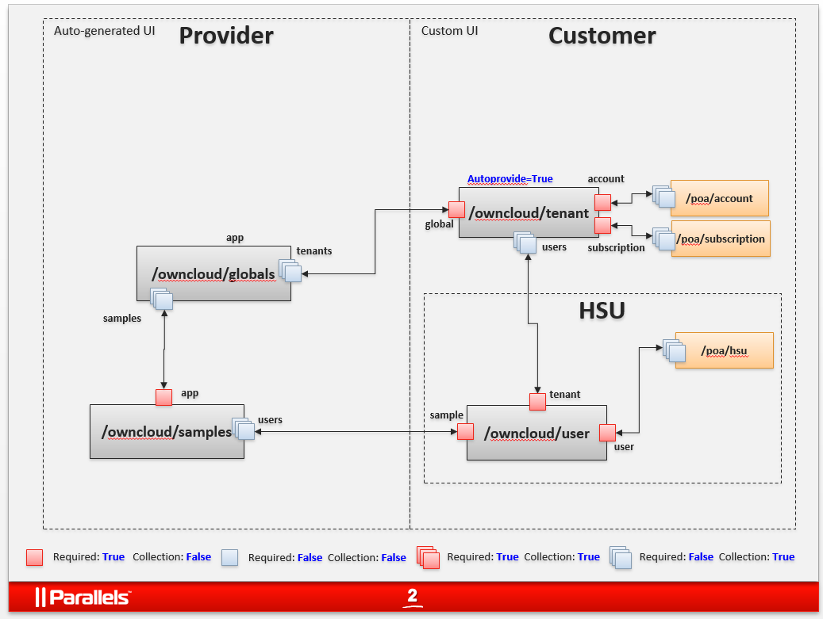

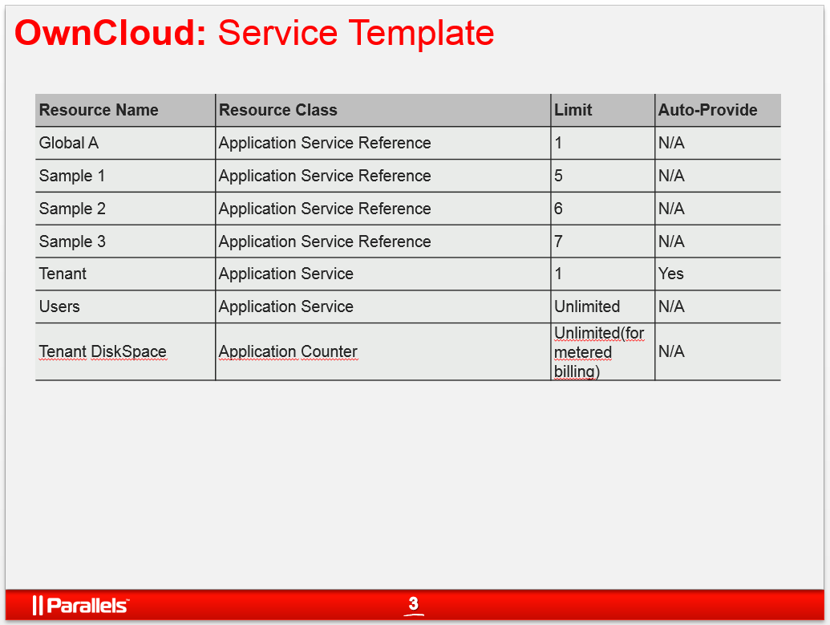

UX Mockups

List of mockups for UI scenarios. Provide screenshots of every screen of the APS application (provider, reseller, customer level).

Customer creates new VPS
